# Revision pane

|  |  |  |  |
| --- | --- | --- | --- |
| **Revision** | **Date** | **Author** | **Notes** |
| 1 | xx/04/24 | JF | Initial document |
|  |  |  |  |

Purpose

This template provides a framework for documenting the use of SOUP (or OTS) software items. It may also be used as a benchmark for existing verification activities. The template includes topics required by clause 5.3.3-5.3.4 and 6.1 of IEC 62304:2006+AMD1:2015.

The template also covers most of the FDA guidance “[Off-The-Shelf Software Use in Medical Devices](https://www.fda.gov/media/71794/download)” (OTS Software Special Documentation is excluded. Special documentation needs to be tailored for each combination of a software system and OTS software.)

The use of SOUPs in medical device software development is widespread and are often constitute valuable assets in a design. This template is to document essential properties of SOUP items and their relationship to the overall software system.

How to use it

1. Use this template as a single source of information for all SOUP items. (Create an individual copy of section 7 for each SOUP item in your design).
2. Use this template to create individual documents for each SOUP item in your design.

In this template, instructions and/or explanations are included using blue italic texts such as these. Instructions and explanations should be removed before review of the document. All texts that are not blue are example texts that can and should be edited by you. Texts that most certainly should be replaced or updated are identified by the { and } characters. They should be removed and the example text customized to work with the current project.

# Purpose

The purpose of this document is to establish documentation for SOUP/OTS in accordance with IEC 62304 and applicable FDA software guidance’s.

The acronym OTS will be used onwards in this document.

# Scope

This SOUP documentation applies to software system “NAME” *{e.g. Visi=Download}.*

# Contents

1 Purpose 1

2 Scope 1

3 Contents 1

4 Abbreviations and acronyms 2

5 Terminology 2

6 Identification of the OTS item(s) 3

7 Investigation of [OTS item #1] 3

7.1 OTS identification and description 3

7.2 OTS risk management 3

7.3 Software system requirements on OTS software 3

7.4 OTS software requirements on the system 4

7.5 End user communication 4

7.6 OTS Maintenance 4

8 References 4

9 Change history 5

Appendix 1, Determination of level of concern 6

# Abbreviations and acronyms

An **abbreviation** is a shortened form of a word or phrase.

**Acronyms** and initialisms are abbreviations formed from the initial components in a phrase or a word.

**NOTE!** If this already exists on project level, reference that source instead of adding a new copy!

|  |  |
| --- | --- |
| **Abbreviation** | **Description** |
| SOUP | Software Of Unknown Provenance |
| OTS | Off The Shelf Software |
| LOC | Level Of Concern |
|  |  |

# Terminology

**Terminology** is the study of **terms** and their use. **Terms** are words and compound words that in specific contexts are given specific meanings, meanings that may deviate from the meaning the same words have in other contexts and in everyday language.

**NOTE!** If this already exists on project level, reference that source instead of adding a new copy!

|  |  |
| --- | --- |
| **Term** | **Description** |
| Minor LOC | Failures or latent design flaws are unlikely to cause any injury to the patient or operator.  Minor LOC is likely to be equivalent to IEC 62340 software safety Class A. |
| Moderate LOC | A failure or latent design flaw could directly, or indirect, result in minor injury, to the patient or operator.  Moderate LOC is likely to be equivalent to IEC 62340 software safety Class B. |
| Major LOC | A failure or latent flaw could directly, or indirect, result in death or serious injury to the patient or operator.  Major LOC is likely to be equivalent to IEC 62340 software safety Class C. |

# Identification of the OTS item(s)

Unambiguously identify the OTS item(s). Preferably refer to existing configuration management planning in a software development plan or development procedures

# Investigation of [OTS item #1]

If you want to keep all OTS information in one document; please copy this chapter and fill out for each applicable OTS.

## OTS identification and description

|  |  |
| --- | --- |
| Internal OTS identification |  |
| Title and Manufacturer of the OTS Software |  |
| OTS Version? |  |

### The rationale for the use of OTS

Why is the software appropriate for this medical device?

### Expected design limitations

Are there any expected limitations with the usage of the OTS software? Such as performance, accuracy, resource consumption?

## OTS risk management

### OTS software hazard analysis

The OTS software is included as a software item in the software system risk analysis documented in SSI-QF-13H Risk Management Plan and VISI-006 Risk Assessment and Implementation Control {or other reference}. Applicable risk control measures are defined and recorded in VISI-006.

### OTS software classification

Classification of SOUP is not required by IEC 62304 but is expected for OTS per FDA guidance. If the software is not intended for the US market, this section could be omitted.

Based on the SSI-QF-20A Software Safety Classification, the level of concern is determined to be:

Minor LOC [ ] Moderate LOC [ ] Major LOC [ ]

### Justification of residual risk

If applicable, summarize the residual risk and justify why it is acceptable compared to developing the OTS software functionality all by yourself.

## Software system requirements on OTS software

### Functional requirements

Preferably reference to existing requirement documents to avoid too many sources of requirements.

### Performance requirements

Preferably reference to existing requirement documents to avoid too many sources of requirements.

### Verification

How is it verified that the OTS software works as expected? If an existing test plan already manages verification, keep it simple and reference existing documentation. See SSI-QF-20E Software Test Protocol

## OTS software requirements on the system

### System hardware requirements

What is required of the SYSTEM hardware to support proper operation of the identified OTS items?

### System software requirements

What is required of the SYSTEM software to support proper operation of the identified OTS items?

## End user communication

Is there a need for communication to end-users to assure they will take appropriate actions?

1. What OTS Software documentation must be provided to the end-user?
2. How will it be communicated?

## OTS Maintenance

### Evaluation of OTS anomalies

Depending on OTS there might be known sources or feed for information about know anomalies of the OTS. Document where to find information.

Preferably reference SSI-QF-20G Software Maintenance Plan for evaluation frequency and how such evaluation will be documented,

### Cybersecurity

Document if the device is networked or not. If networked; what measures will be taken to maintain a safe product from a cybersecurity perspective?

# References

References shall be stated with both document **number** and **title.**

1. IEC 62304 Medical device software – Software life cycle processes
2. OTS Guidance FDA - Off-The-Shelf Software[1]
3. Xxx Software risk analysis
4. Xxx Other documents

# Appendix 1, Determination of level of concern

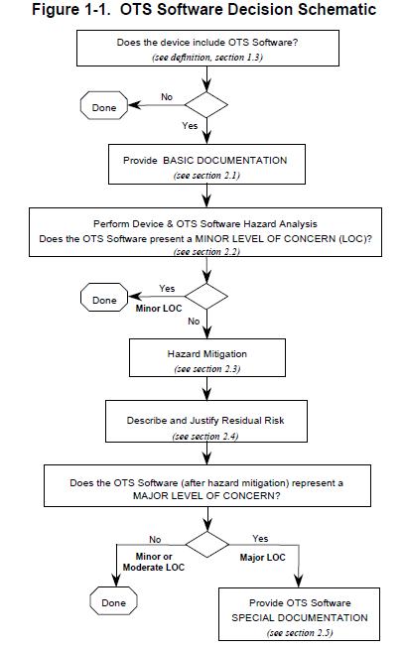

1. https://www.fda.gov/regulatory-information/search-fda-guidance-documents/shelf-software-use-medical-devices